Name | Muhammad Saad Ali
REG. No | DSAI241103089
Section | 3B

Lab 3: Subnetting and IP Address Assignment

Objective:
The objective of this lab is to help students understand the concept of subnetting and practice dividing a network into smaller sub-networks. Students will also learn how to assign IP addresses to different hosts based on their subnet calculations.

Introduction:
Subnetting is the process of dividing a larger network into smaller, more manageable segments known as subnets. It improves network performance, enhances security, and allows efficient use of IP address space. Understanding how to calculate subnets, determine valid host ranges, and assign IPs correctly is a fundamental skill in networking.

This lab focuses on calculating subnets manually and applying those calculations by assigning IP addresses to devices in a local network.

Key Concepts:

- IP Address:
An IP address identifies a device on a network. It consists of a network portion and a host portion.

- Subnet Mask:
A subnet mask determines how many bits belong to the network and how many belong to hosts. It helps divide an IP address into network and host components.

- Network ID and Broadcast ID:
• The **Network ID** is the first address of a subnet and identifies the subnet itself.
• The **Broadcast ID** is the last address in the subnet and is used to send messages to all devices within that subnet.

- Host Range:
The addresses between the network ID and broadcast ID are valid for assigning to devices.

- CIDR Notation:
CIDR (Classless Inter-Domain Routing) represents subnet masks using a slash, such as /24 or /26, indicating how many bits are used for the network.

Subnetting Procedure:
Students will learn how to:
• Determine the number of required subnets.
• Calculate the new subnet mask.
• Identify the block size.
• List each subnet’s network ID, broadcast ID, and valid host range.
• Assign IP addresses according to subnet divisions.

Lab Activities:

- Perform subnetting on a given Class C network (e.g., 192.168.10.0/24).
Given Network: 192.168.10.0/24
Number of Subnets Required: 4
Borrowed Bits: 2
New Subnet Mask: 255.255.255.192 (/26)
Number of Hosts per Subnet: 62
- Calculate four equal subnets and determine their network IDs and broadcast IDs.
Subnet 1:
- Network ID: 192.168.10.0
- Broadcast ID: 192.168.10.63 (Network + 63)
Subnet 2:
- Network ID: 192.168.10.64
- Broadcast ID: 192.168.10.127
Subnet 3:
- Network ID: 192.168.10.128
- Broadcast ID: 192.168.10.191
Subnet 4:
- Network ID: 192.168.10.192
- Broadcast ID: 192.168.10.255

- Write valid host ranges for each subnet.
- Subnet 1
Host Range: 192.168.10.1 – 192.168.10.62
- Subnet 2
Host Range: 192.168.10.65 – 192.168.10.126

- Subnet 3
Host Range: 192.168.10.129 – 192.168.10.190

- Subnet 4
Host Range: 192.168.10.193 – 192.168.10.254

- Assign appropriate IP addresses to devices such as PCs, switches, and routers based on the calculated subnets.
Assigning Ip address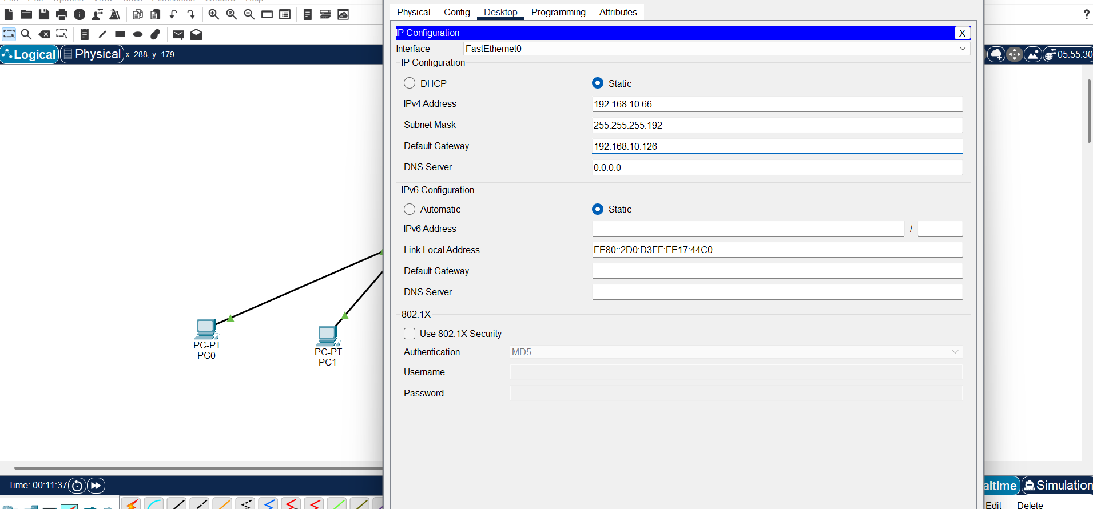
Routers IP 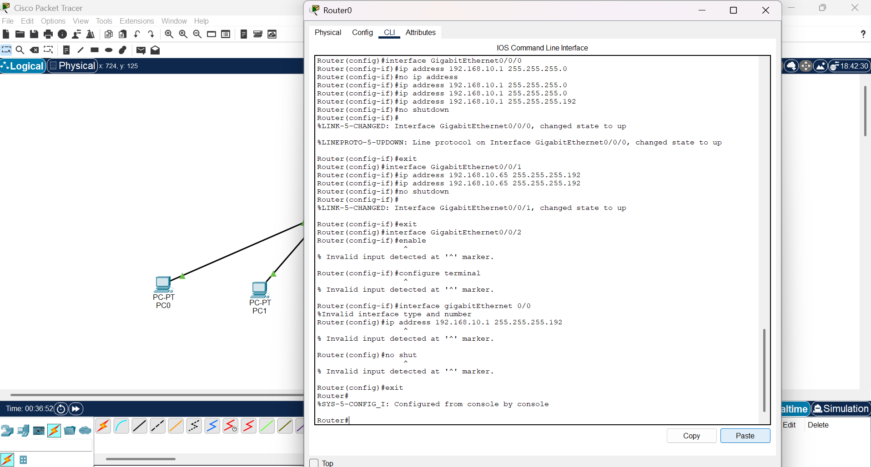
Switches IP 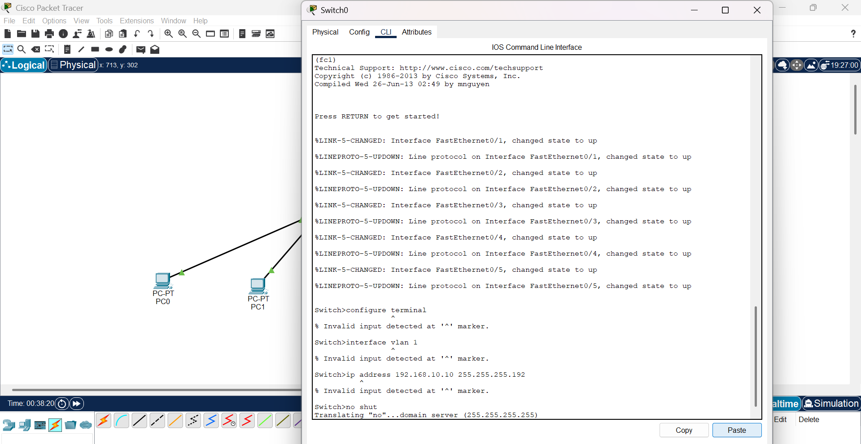
- Verify connectivity between devices using ping (if using Packet Tracer or a real network).
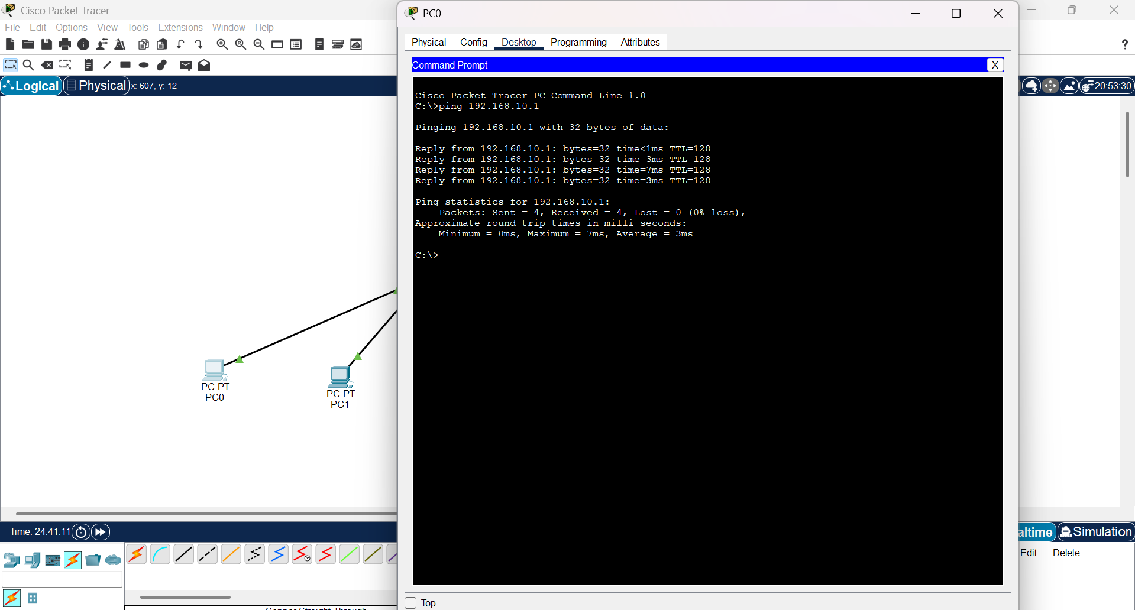

Example Task:
Given the network **192.168.1.0/24**, divide it into **4 subnets**.
Students must calculate:
• New subnet mask (/26)
• Block size (64)
• Subnet ranges:

* 192.168.1.0 to 192.168.1.63
* 192.168.1.64 to 192.168.1.127
* 192.168.1.128 to 192.168.1.191
* 192.168.1.192 to 192.168.1.255

Expected Outcomes:
• Explain the purpose and advantages of subnetting.
• Perform manual subnet calculations accurately.
• Determine network ID, broadcast ID, and host ranges for each subnet.
• Assign correct IP addresses to devices based on subnetting.
• Verify communication between devices within and across subnets.

